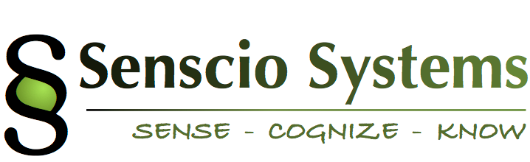

October 20, 2015

Senscio Systems

1740 Massachusetts Avenue

Boxborough, MA 01719

Subject: Letter Contract

This Letter Contract effective as of June 1, 2015 is made by and between Senscio Systems, Inc., having its principal place of business at 1740 Massachusetts Ave., Boxborough, MA 01719, and______________________ (the “Licensee” or “”), a non-profit corporation organized in _______________, having its principal place of business at ____________________________________.

Statement of Work:

Senscio Systems will provide equipment, software and support services for a project as outlined below:

* Ibis systems for a minimum of 50 individuals throughout the agency network:
  + Individuals shall be selected by the appropriate agency staff.
  + Installation, training and technical support will be provided by Senscio personnel.
  + This initial project will be based on current capabilities (protocols and alert systems) included in the Ibis system and any additional enhancements provided over the course of the project by Senscio Systems.
* Routine 24x7 monitoring of each enrolled individual’s health and adherence alerts will be provided by Senscio Systems with notifications and handoffs to the appropriate agency staffs, as agreed.
* Senscio will provide analytics on health and behavioral trends for each enrolled individual.
* Care Navigation support for onboarding and ongoing operations including……
* The project will start no later than Dec 1, 2015 and continue for a period of one year.

The final Quote with terms for the Ibis system and associated services is included as an attachment to this letter.

A few additional details are:

* The contract will automatically renew on an annual basis, with any changes in price to be negotiated in good faith unless written notification is provided 60 days prior to the applicable expiration date.
* Senscio will appoint a project manager to work with your designated project manager to serve as the primary point of contact for all project related issues.
* A Business Associates Agreement for your signoff.
* Following execution of this Letter Contract, a formal contract containing all required legal documents will be executed and include, but not be limited to:
  + Support Services Agreement
  + Hardware Lease and Software License Agreement
  + Agreed Delivery Schedule
  + Ibis Protocols and Service Support Processes

State a bit more from standard language:

The parties signify their agreement by signing below:

__________________________ ___________________

Community Support Providers Date

Of South Dakota

___________________________ ____________________

Senscio Systems Date

Attachments:

Final Quote and Terms

Business Associates Agreement

Appendix X to BAA